**LAB WORK-10**

**01.Write a C++ Program to print user roll, name (Input name through Terminal).**

**CODE:**

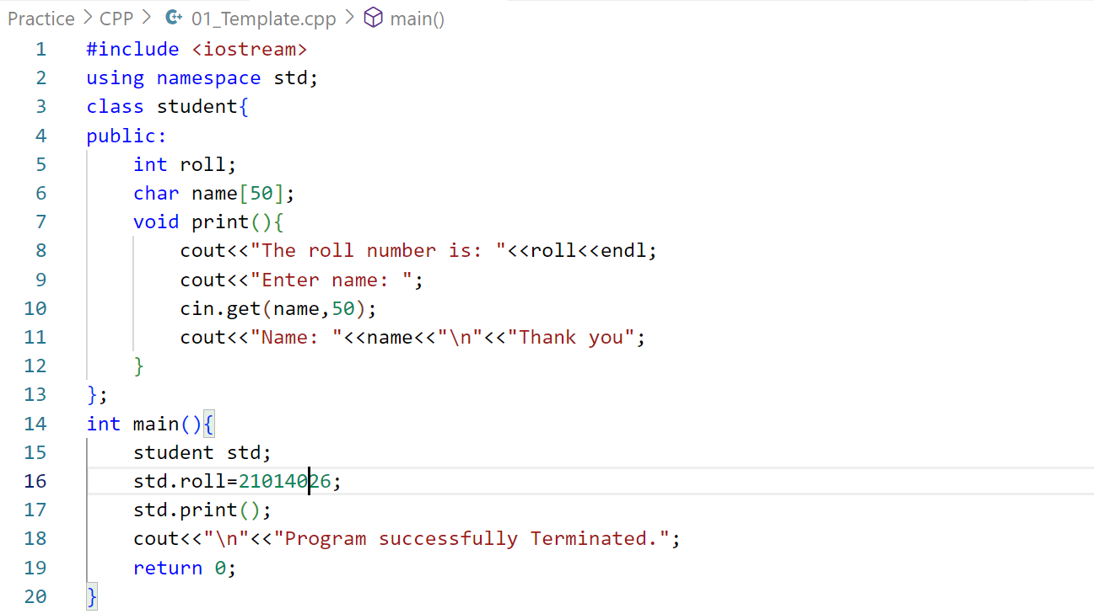

**OUTPUT:**

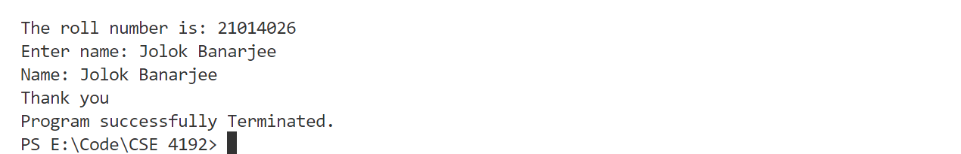

**02.Write a C++ Program to find area and volume of a, b, c using private and public access specifier.**

**CODE:**

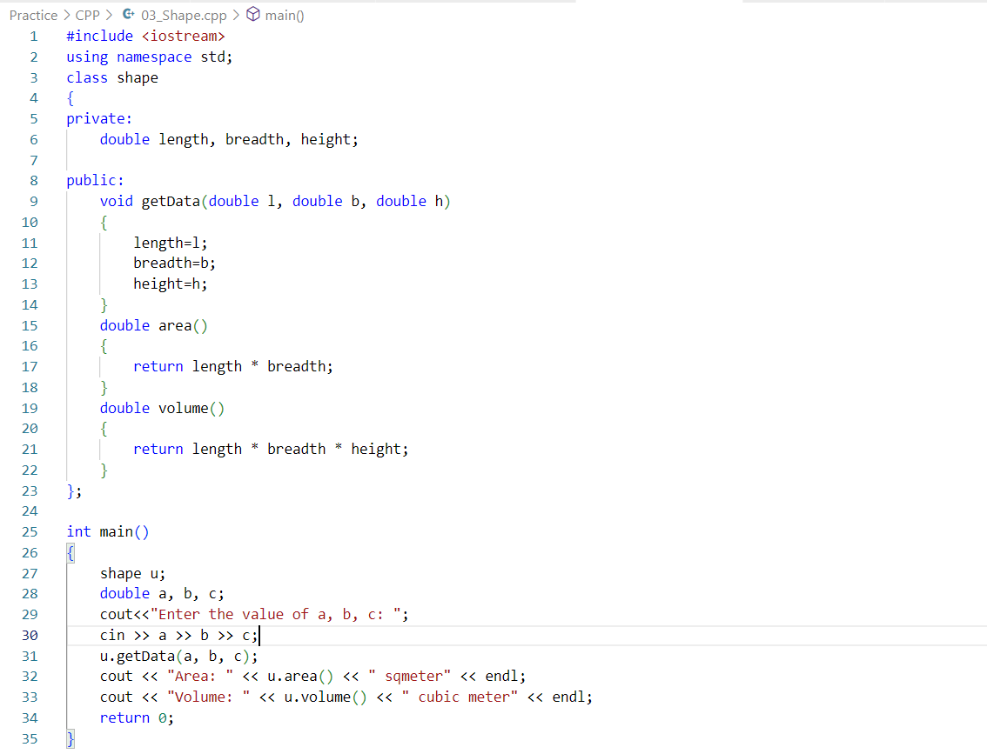

**OUTPUT:**

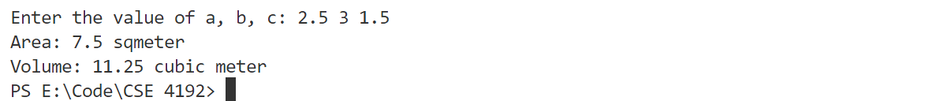

**03.Write a C++ Program to print user information using Inheritance.**

**CODE:**

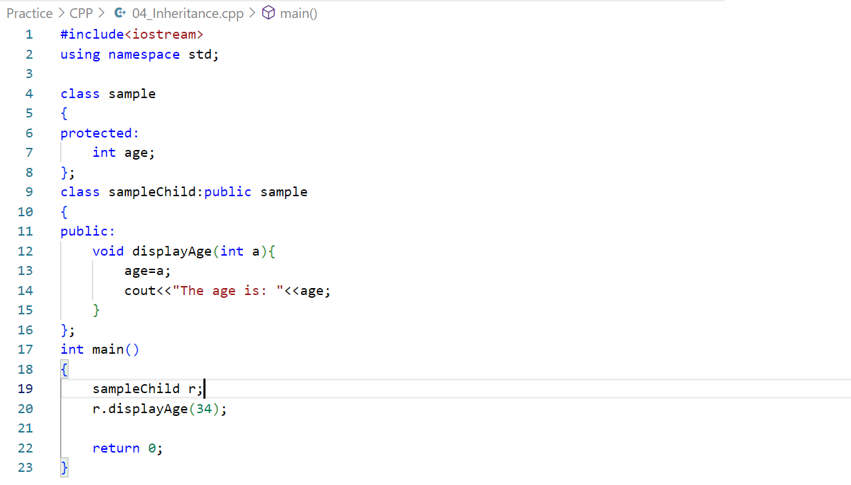

**OUTPUT:**

